**PRACTICAL 2**

**AIM: Study of different types of motes and deploy them using IoT architecture. Simulate Hello World program using Cooja.**

**IMPLEMENTATION:**

Step 1: Create new simulation. Name the simulation.

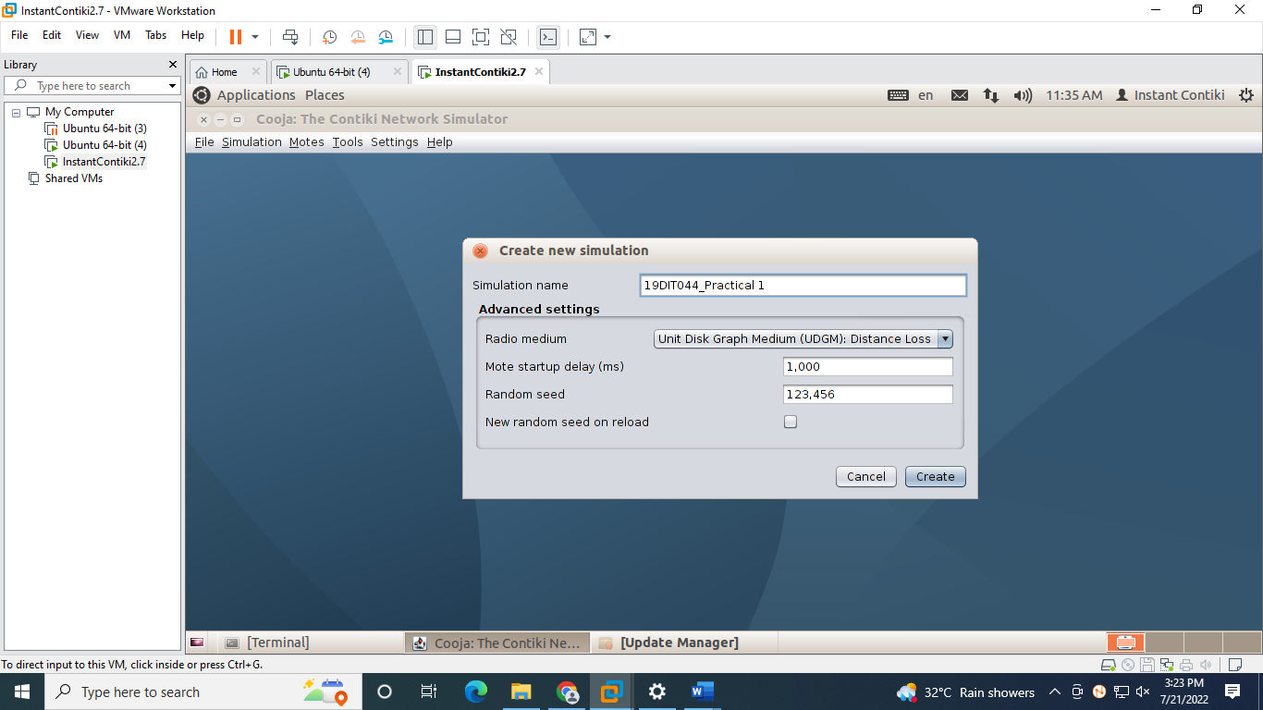

Step 2: We get an output screen shown in the screenshot.

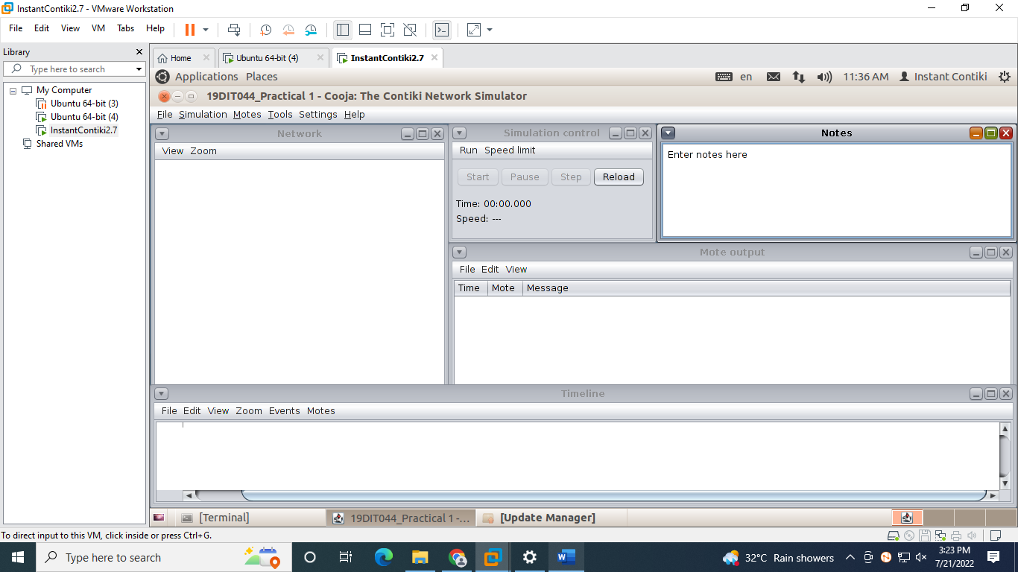

Step 3: Navigate to **Motes > Add motes > Sky mote.** Now you will get a new panel as shown below.

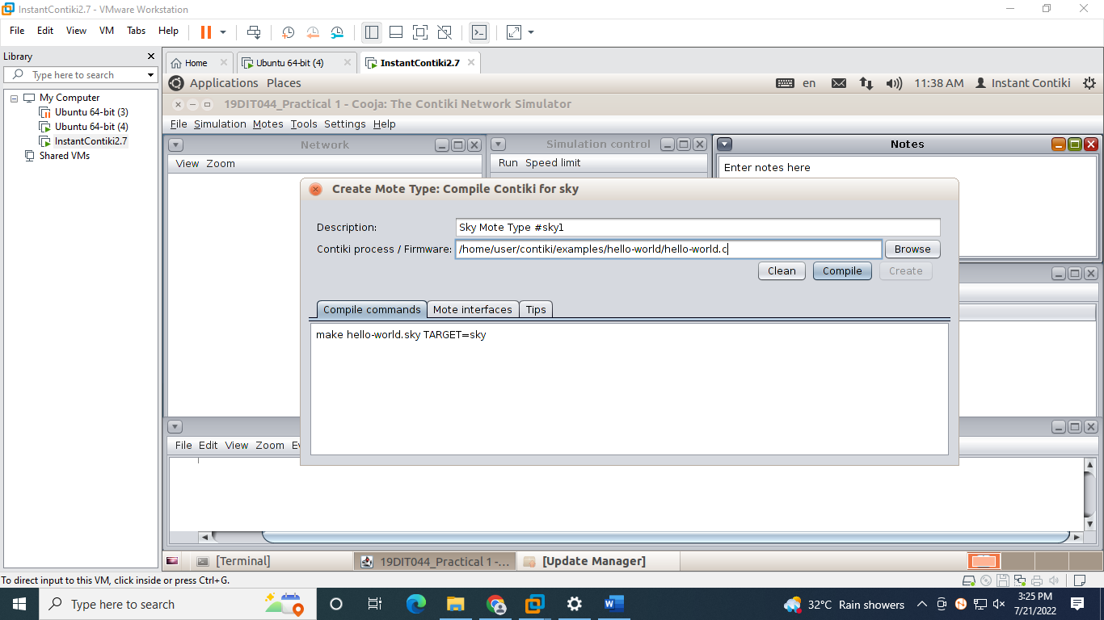

Step 4: Click browse and navigate to **contiki-2.7/examples/hello-world/hello-world.c**and press **Compile.**

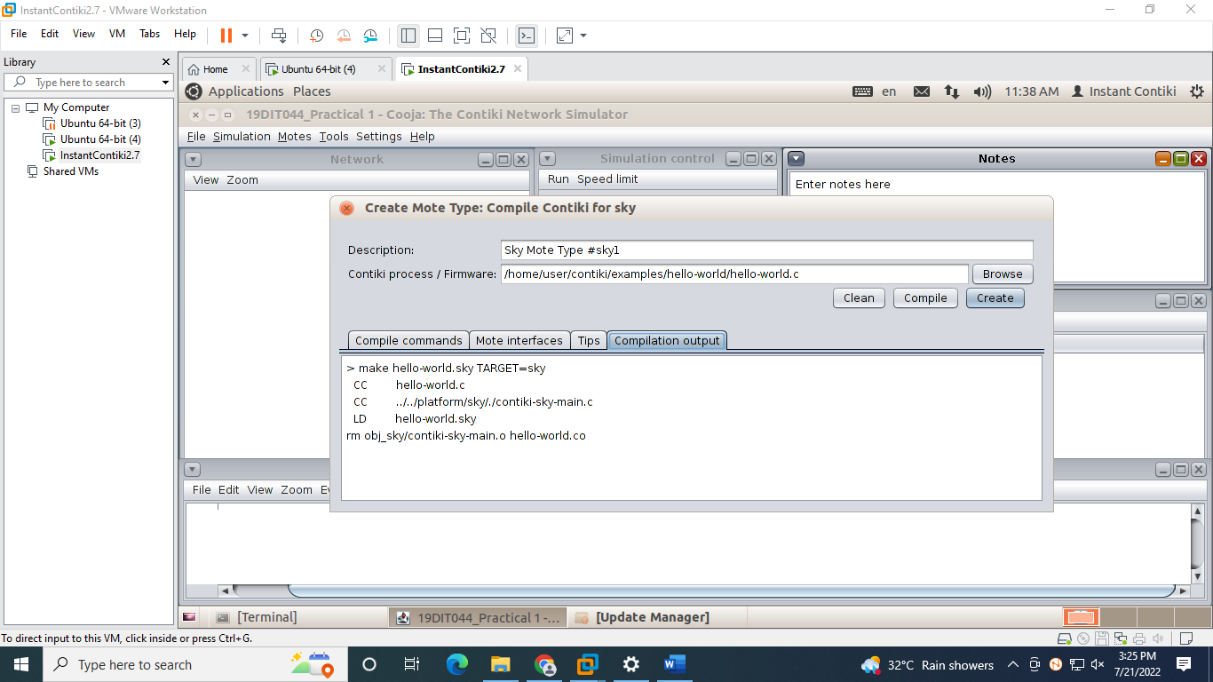

Step 5: After compilation press the Create button. You will get an option to add motes. Add 5 Motes.

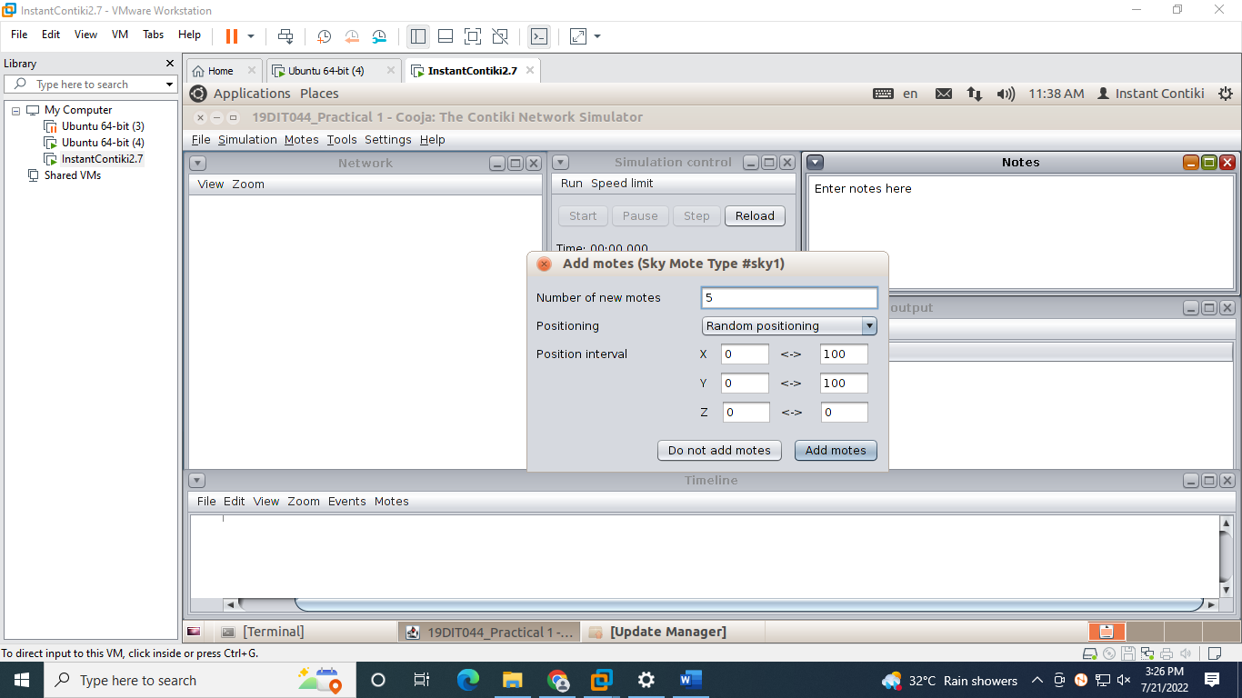

Step 6: You will get an output screen.

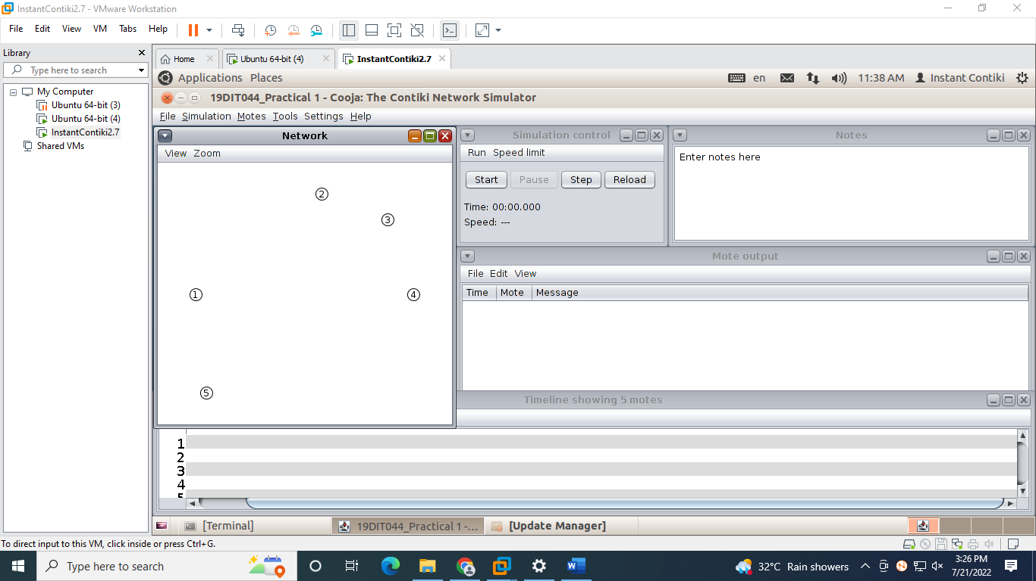

Step 7: Now click on View and select Mote IDs, Log output: printf()’s, LEDs, Radio Traffic, 10m background grid, Mote Type and Radio environment. And start the simulation.

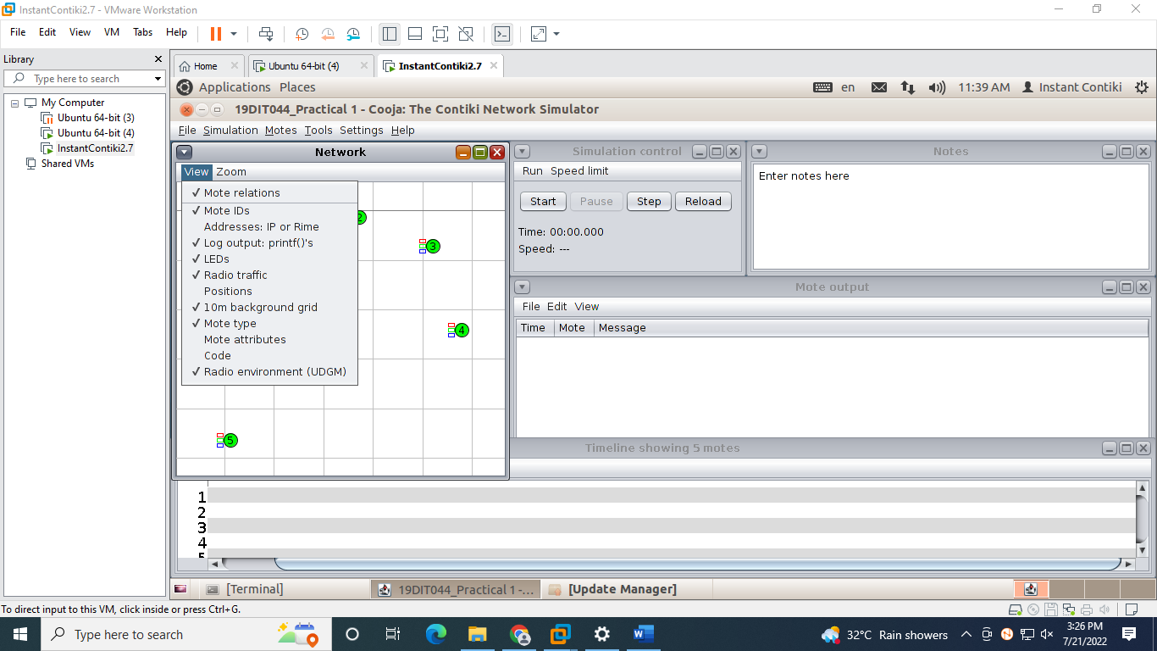

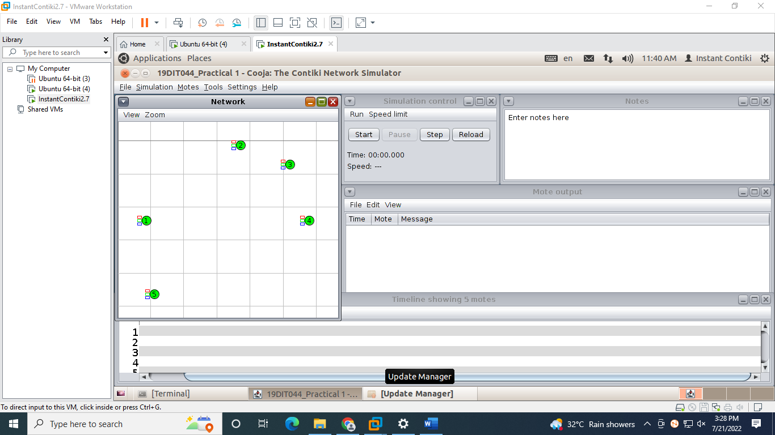

Step 8: Final output looks like in the screenshot.

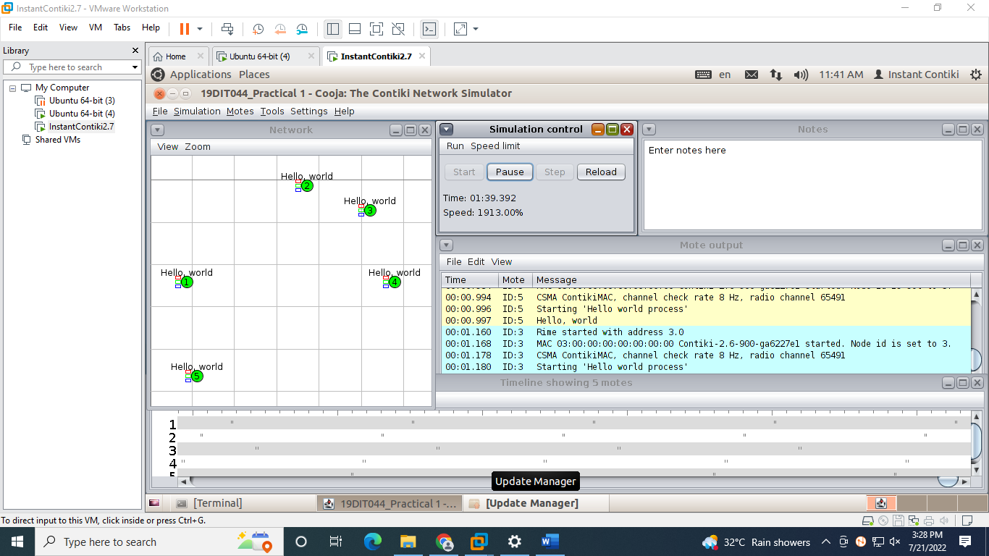

**OUTPUT:**

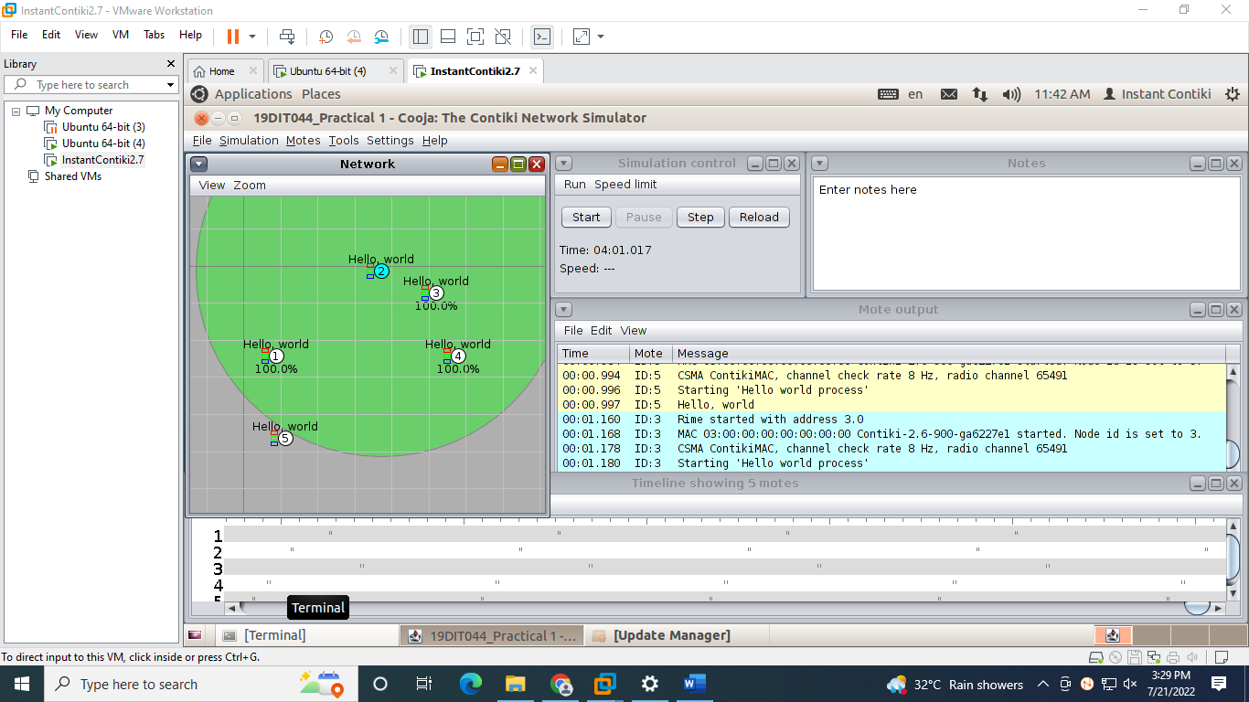

**CONCLUSION:**

From this practical, I learned about how to simulate a C program in Instant Contiki OS with Cooja. Also I explored various views of the network.